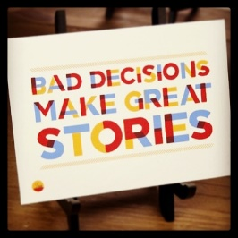 Key Stage 3 History – Years 7-9

It is true that in the past man has made some interesting decisions and many have had repercussions on today´s society. In order to understand who we are and where we come from we need to consider different aspects of the past, understand people´s motives for their different actions and beliefs and evaluate their significance on our lives today. In KS3 we aim to teach a broad overview of events in international history from the 11th century to modern day and use this knowledge to analyse and evaluate the actions of man so that we can repeat those things which have changed our lives for the better and reframe from repeating those which have not.

Over three years students will cover the following topics as well as completing different independent projects at home. They will awarded different British National Curriculum levels, so they can monitor their academic progress, as well as effort grades to award their fantastic attitude towards their work.

Year 7 | Year 8 | Year 9
Who has the power?  A history of conquer and control from1066 – 1603?  What was life like for people like me?  A study of everyday life from 1000 to 1603  How and why did people move around?  An international study from 1000 to 1603 | Power to the people!  Why did the English cut off their King´s head?  Progress, poverty and putrid conditions  A history of changing views and attitudes 1603-1901  The rise and fall of Empires  How did Europe try to take over the world?  Different but equal?  A history of America from slavery to civil rights | A war to end all wars?  A History of World War One  Votes for women!  Did women get the vote because of the Great War?  The rise of the dictators!  Why was democracy so unpopular in the 1920s/30s  From one war to another  How did WW1 lead to second world war in just 20 years?

IN THE CLASSROOM

In class we will be using a variety of teaching methods which will serve a variety of learning styles to suit everyone. We will be using textbooks, writing essays, holding debates and analysing pictures sources. We will also be asking the students to carry out independent research as well as teaching others and even acting out historical events. We hope this will bring History to life and ensure the students will find the subject both challenging and rewarding and possibly continue this onto Key Stage 4.

SUPPORTING YOUR CHILD

Pupils should be encouraged to read and watch the news as much as possible. They will find that this improves their vocabulary and English language, which is so important in History and will help them to achieve the higher levels. In addition historical fiction can provide a good foundation for understanding the past and relating it to our lives today.

Nicola Worsfold, Head of Humanities, St George´s School, Seville

